Lab 11:

1. Write SQL code to create alias name of existing entities
2. Create table Teacher with suitable fields.
   1. Insert seven records
   2. Give increment of 30% of salary of Computer Department
   3. Give increment of 50% of salary who works more than 10 years
   4. Find the highest paying and lowest paying teacher from Math Department

SQL Query:

* CREATE DATABASE db11;

USE db11;

* CREATE TABLE teacher (

teacher_id INT PRIMARY KEY,

teacher_name VARCHAR(100),

department VARCHAR(50),

salary INT(6),

years_of_experience INT

); 

* INSERT INTO teacher (teacher_id, teacher_name, department, salary, years_of_experience) VALUES

(1, 'Anshu Hada', 'Math', 50000, 12),

(2, 'Barsha Pandey', 'Computer', 60000, 9),

(3, 'Gaurav Thapa', 'Math', 55000, 7),

(4, 'Manila Aryal', 'Computer', 62000, 11),

(5, 'Shrisha Tuladhar', 'Physics', 52000, 15),

(6, 'Sudip Khadka', 'Computer', 58000, 4),

(7, 'Sangam Adhikari', 'Math', 49000, 10);

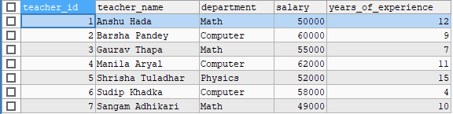

* UPDATE teacher

SET salary = salary * 1.30

WHERE department = 'Computer'; 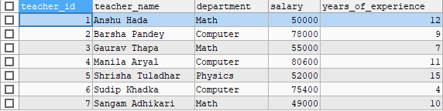

* UPDATE teacher

SET salary = salary * 1.50

WHERE years_of_experience > 10; 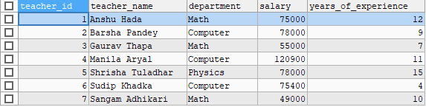

* SELECT *

FROM teacher

WHERE department = 'Math'

AND salary = (SELECT MAX(salary) FROM teacher WHERE department = 'Math'); 

SELECT *

FROM teacher

WHERE department = 'Math'

AND salary = (SELECT MIN(salary) FROM teacher WHERE department = 'Math'); 

SELECT

teacher_id AS ID,

teacher_name AS NAME,

department AS Dept,

salary AS Salary,

years_of_experience AS Experience

FROM teacher;

